6.

SELECT E.EMPNO, E.NAME, J.JOB_DESCR, J.SAL, E.DEPTNO

FROM EMP E, JOB J

WHERE E.JOBNO = "100"

AND J.JOBCODE = "100";

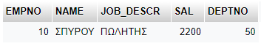

7.

SELECT MAX(J.SAl) AS MAXSAL, MIN(J.SAl) AS MINSAL, AVG(J.SAl) AS AVGSAL, COUNT(J.SAl) AS GOTSAL, COUNT(COMM) AS GOTCOMM, COUNT(*) AS NUMOFEMP

FROM JOB J, EMP E

WHERE J.JOBCODE=E.JOBNO;



8.

SELECT MAX(J.SAL) AS MAXSAL, AVG(J.SAL) AS AVGSAL

FROM JOB J

WHERE J.JOB_DESCR = "ΠΩΛΗΤΗΣ";

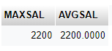

9.

SELECT E.EMPNO, E.NAME, J.JOB_DESCR, J.SAL, E.DEPTNO

FROM EMP E, JOB J

WHERE E.JOBNO = "200"

AND J.JOBCODE = E.JOBNO

AND J.SAL BETWEEN 1000 AND 2500;

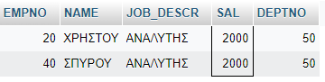

10.

SELECT E.EMPNO, E.NAME, J.JOB_DESCR, J.SAL, E.DEPTNO

FROM EMP E, JOB J

WHERE NAME LIKE "%Ρ%"

AND J.JOBCODE = E.JOBNO;

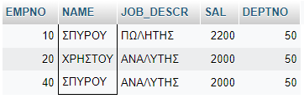

11.

SELECT E.EMPNO, E.NAME, J.JOB_DESCR, J.SAL, E.DEPTNO

FROM EMP E, JOB J

WHERE E.JOBNO = J.JOBCODE

ORDER BY E.DEPTNO, J.SAL;

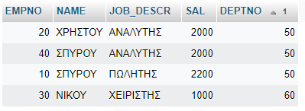

12.

SELECT E.DEPTNO, AVG(J.SAL) AS AVGSAL, COUNT(E.EMPNO) AS EMPCOUNT

FROM EMP E JOIN JOB J ON J.JOBCODE = E.JOBNO

GROUP BY E.DEPTNO;

